TITLE : - Cyber Défense Agent Swarm – AI Powered Threat Intelligence System
Guide: Dr. Rashmi Kale Chattani
Name | Roll No: | PRN | Department
Shreyas Mulavekar | 7 | 12310795 | TY - CS-C
Ritesh Nimbalkar | 18 | 12311603 | TY -CS-C
Palash Poojary | 23 | 12310364 | TY- CS-C
Sachin Prasad | 44 | 12310646 | TY -CS-C
Tables of content:
- Introduction
- Literature Review
- Objectives
- Tools and Technologies
- System Architecture
- Methodology
- Dataset Description
- Model Training and Evaluation
- Results
- Conclusion
- Future Scope
- References

1. Abstract
This project presents an AI-driven cyber defense system capable of detecting and classifying malicious network traffic in near real time. The solution uses supervised machine learning models trained on the UNSW-NB15 intrusion detection dataset and integrates them with a multi-agent framework that automates monitoring, analysis and remediation. A large language model (LLM) powered by the Groq API is used to generate human-readable explanations of detected threats and to suggest mitigation actions. The system is deployed through a Streamlit-based web interface that provides visual analytics, attack classification, explanation of model decisions and recommended responses. Experimental results show that ensemble models such as Random Forest and XGBoost achieve competitive performance on multi-class attack detection, demonstrating the feasibility of a self-healing, AI-assisted cyber defense architecture suitable for Security Operations Center (SOC) environments.
2. Literature Review

Paper | Implementation / Findings
UNSW-NB15 Dataset Design (Moustafa & Slay) | Introduced the UNSW-NB15 dataset, which contains realistic benign and malicious network traffic with multiple attack categories. It is widely used as a benchmark for IDS research.
Machine Learning for Intrusion Detection (Aljawarneh et al.) | Evaluated various machine learning classifiers such as Decision Trees, Random Forests and Logistic Regression on intrusion detection tasks, showing that ensemble models often achieve higher accuracy.
Deep and Ensemble Models for IDS (Chen et al.) | Proposed hybrid approaches combining deep learning and gradient boosting (e.g., XGBoost) to improve detection of complex attack patterns in large-scale network traffic.
Explainable AI in Cybersecurity (Das et al.) | Discussed the need for interpretability in security models and introduced methods such as SHAP and LIME to explain model predictions to human analysts.
Multi-Agent Cyber Defense Automation (Khan & Arora) | Explored the use of software agents for automated threat detection, decision making and response in SOC environments, motivating the multi-agent design adopted in this work.

3. Objectives

The main objectives of this project are:
- To design and implement a multi-class intrusion detection system using machine learning on the UNSW-NB15 dataset.
- To classify network events into attack types such as DoS, Exploits, Fuzzers, Generic, Reconnaissance, Shellcode, Worms and Normal traffic.
- To integrate an AI-based multi-agent framework that automates monitoring, analysis, explanation and remediation.
- To generate explainable outputs describing why an attack was predicted and how it can be mitigated.
- To build a Streamlit web interface that allows users to interact with the system, visualize predictions and view Groq-generated security reports.

4. Tools and Technology Used:
- Programming Language: Python
- Machine Learning Libraries: Scikit-Learn, XGBoost, NumPy, Pandas
- Model Persistence: Joblib, optional ONNX export for portability
- Dataset: UNSW-NB15 (training and testing CSV files)
- Frontend / Dashboard: Streamlit
- Explainability (XAI): SHAP (for feature influence analysis)
- LLM Integration: Groq API (Llama-3.3-based models) for natural language threat explanation and remediation guidance
- Environment: Local Python 3.x virtual environment / IDE

5. System Architecture:

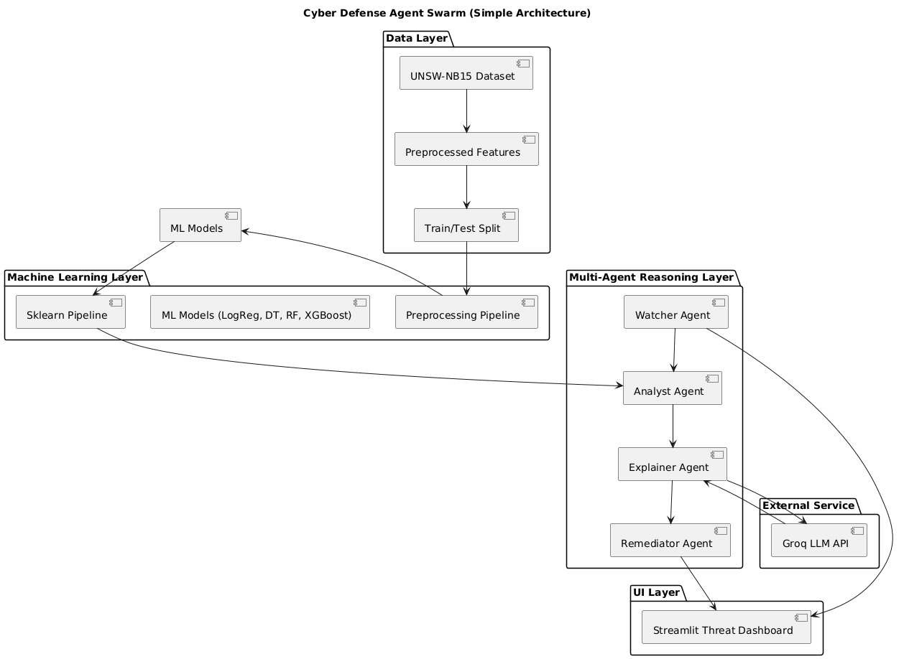

6. Methodology:
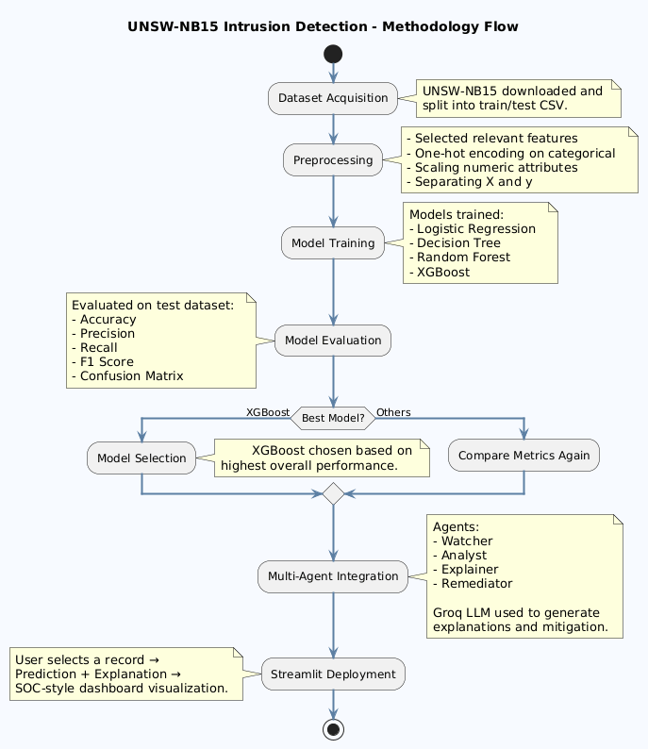

7. Dataset Description:
The UNSW-NB15 dataset was generated using the IXIA PerfectStorm tool at the Australian Centre for Cyber Security. It contains modern synthetic network traffic including both legitimate and malicious flows.
Key characteristics:
- Multiple attack categories, such as:
  - Fuzzers, Analysis, Backdoor, DoS, Exploits, Generic, Reconnaissance, Shellcode, Worms and Normal.
- Features:
  - Flow duration, protocol type, service, state, packet counts, byte counts, TCP flags, connection statistics and content-based attributes.
- Labels:
  - attack_cat (attack category) and label (binary normal/attack).
In this project, the focus is on multi-class classification using attack_cat as the target variable.

8. Model Training and Evaluation:

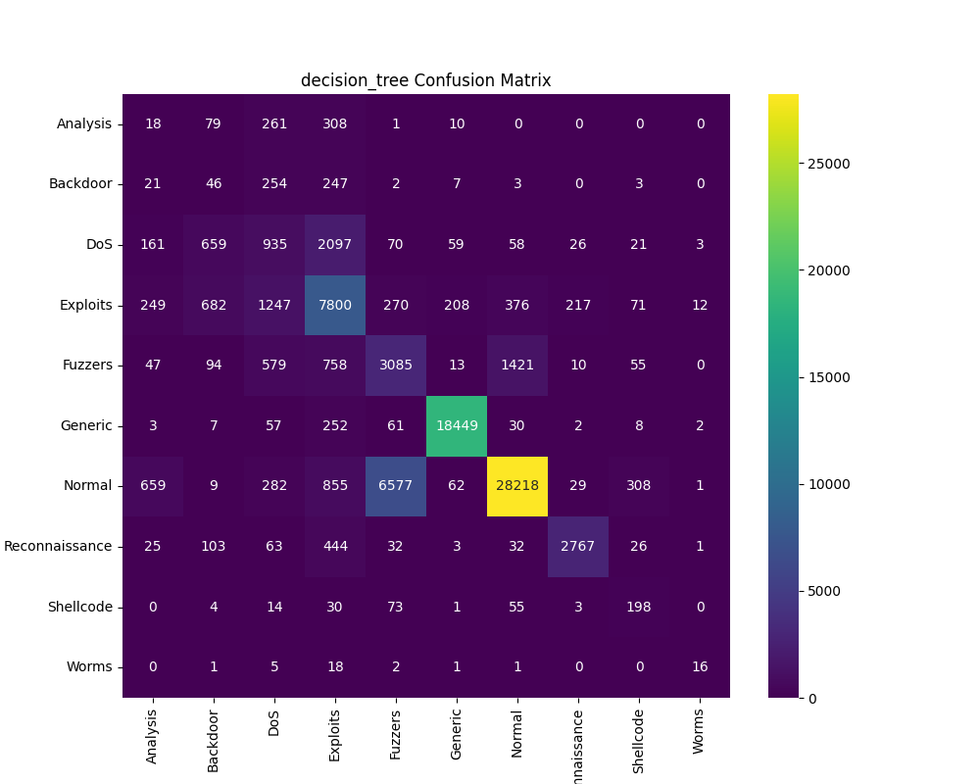
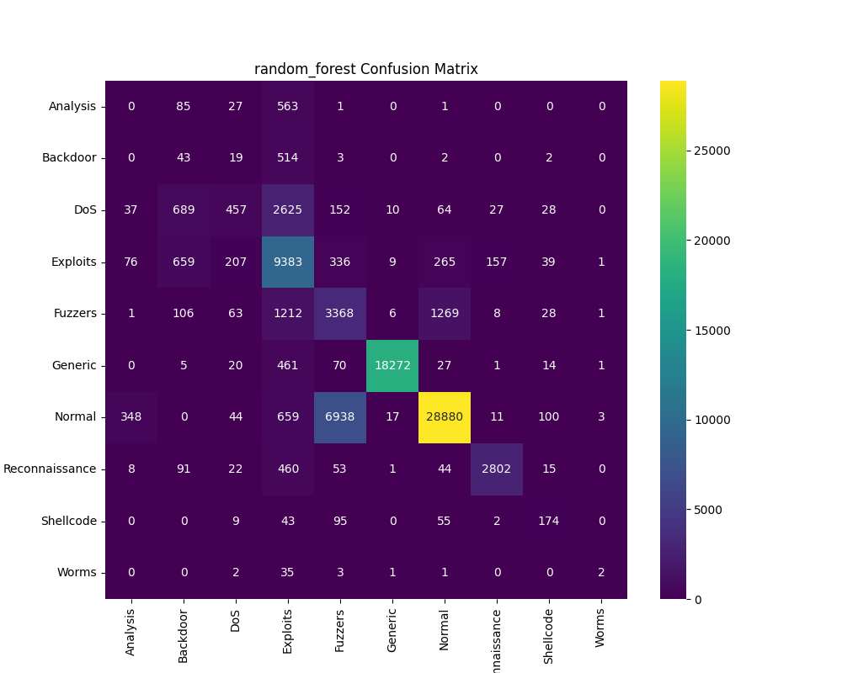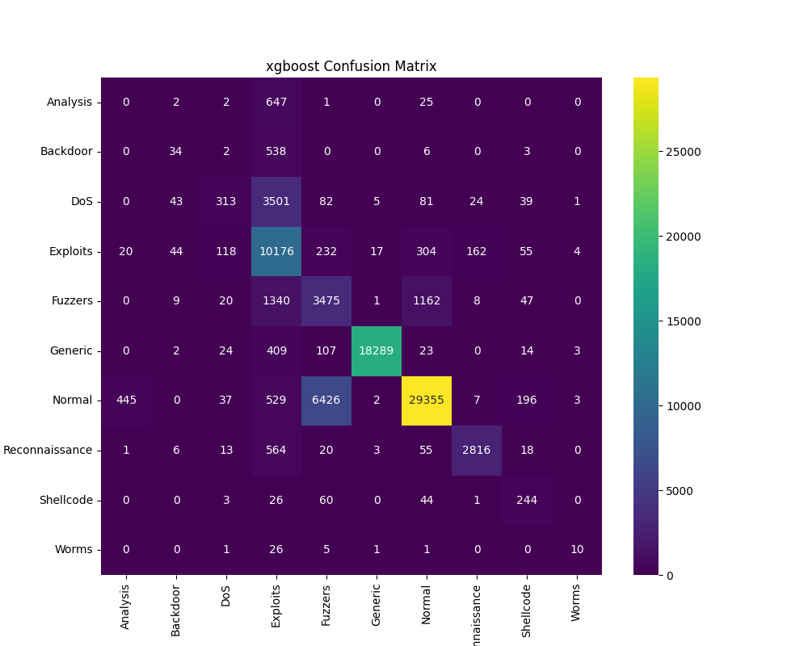
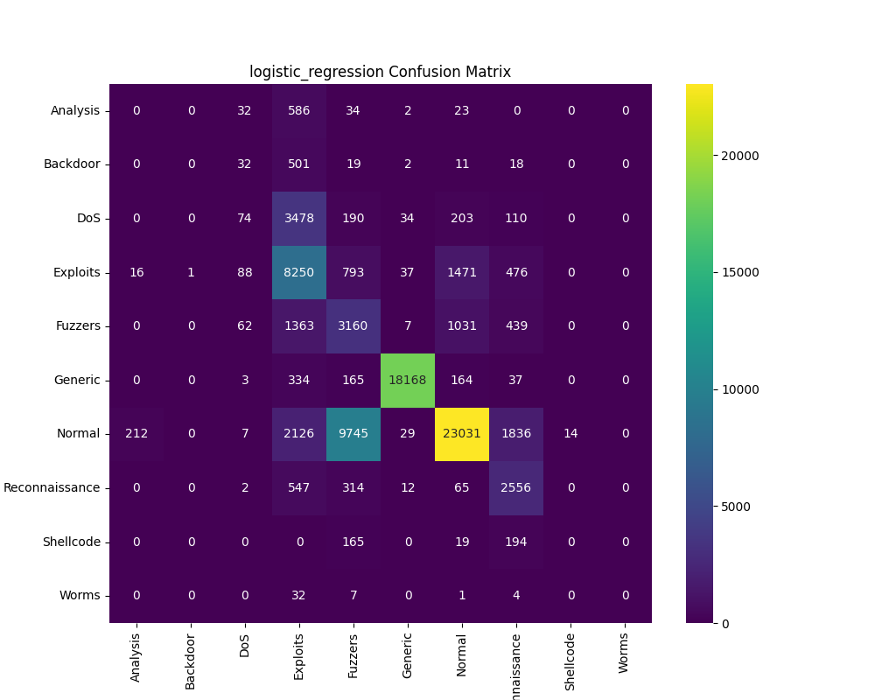

9. Results:

Model | Accuracy | Precision | Recall | F1-Score
Logistic Regression | 0.6709 | 0.3272 | 0.3597 | 0.3188
Decision Tree | 0.7474 | 0.4773 | 0.4963 | 0.4772
Random Forest | 0.7698 | 0.5002 | 0.4640 | 0.4532
XGBoost | 0.7860 | 0.5486 | 0.5063 | 0.4865

From the results, XGBoost achieves the highest accuracy and precision, making it the most suitable model for deployment. Decision Tree and Random Forest also show strong performance, while Logistic Regression lags due to the non-linear nature of the data.

10. Conclusion:

The project successfully implements a self-healing, AI-assisted cyber defense system that:
- Detects and classifies multiple categories of cyber attacks using supervised learning.
- Integrates a multi-agent framework that automates monitoring, prediction, explanation and remediation suggestion.
- Uses Groq’s LLM to convert raw model outputs and features into human-readable threat intelligence.
- Exposes all functionality through an interactive Streamlit UI that resembles a SOC dashboard.
The experimental results confirm that XGBoost performs best on the UNSW-NB15 dataset among the evaluated models. The combination of ML-based detection and LLM-based explanation demonstrates a practical path towards more autonomous and interpretable cyber defense systems.

11. Future Scope
Possible extensions of this work include:
- Real-time packet capture integration using tools such as Wireshark or Scapy, enabling live traffic monitoring instead of static CSV input.
- Automatic firewall rule updates based on detected threats and analyst approval, forming a closed-loop response system.
- Adaptive or online learning that updates the model as new types of attacks are observed.
- Cloud or container deployment so that the system can be scaled and integrated with enterprise SOC infrastructure.
- Integration with SIEM platforms to correlate alerts from different sources.

12. References
- UNSW-NB15 Dataset – Australian Centre for Cyber Security.
- Moustafa, N., & Slay, J. – “UNSW-NB15: A Comprehensive Data Set for Network Intrusion Detection Systems.”
- Scikit-Learn Documentation – Machine Learning in Python.
- XGBoost Documentation – Scalable Tree Boosting System.
- Streamlit Documentation – Data App Framework.
- GroqCloud / Groq LLM API Documentation.

